1. a)

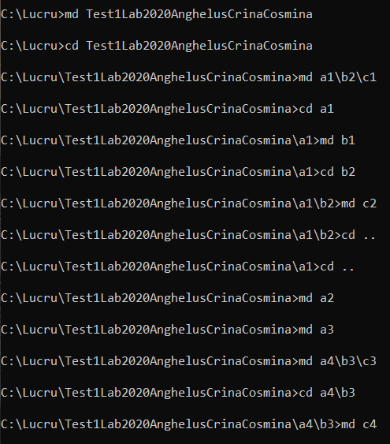

b)

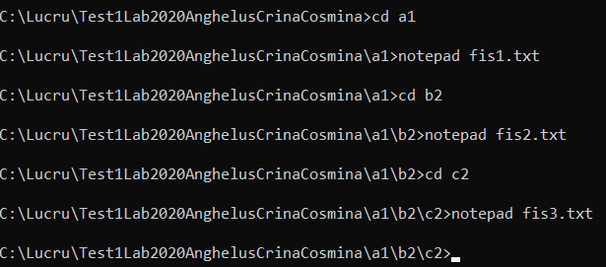

c)

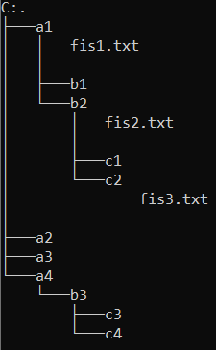

d)

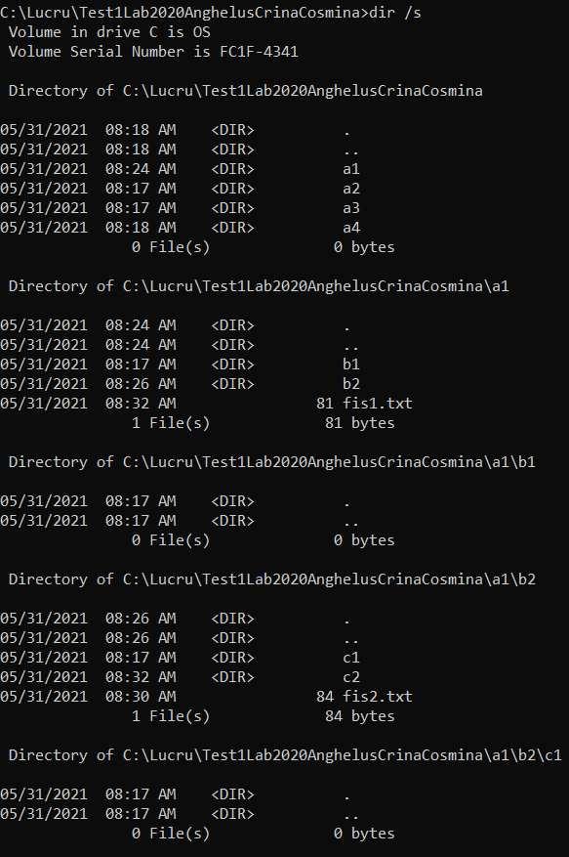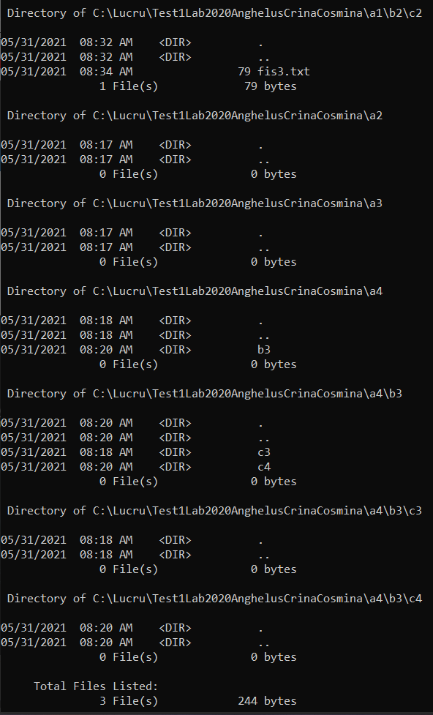

e)

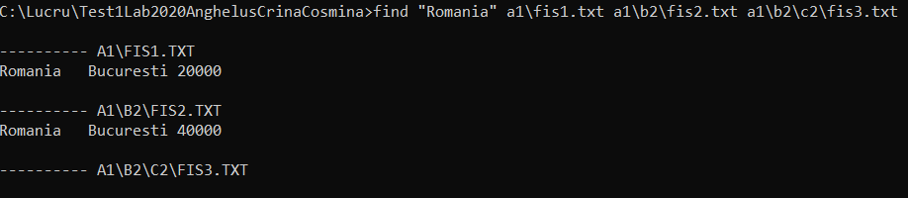

f)

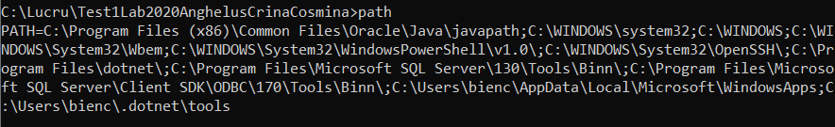

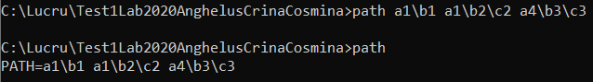

g)

:repeta

shift

if "%1"=="" goto :sfarsit

if exist %1\\* (

echo "%1 este director"

) else (

echo "%1 nu este director"

)

goto :repeta

:sfarsit

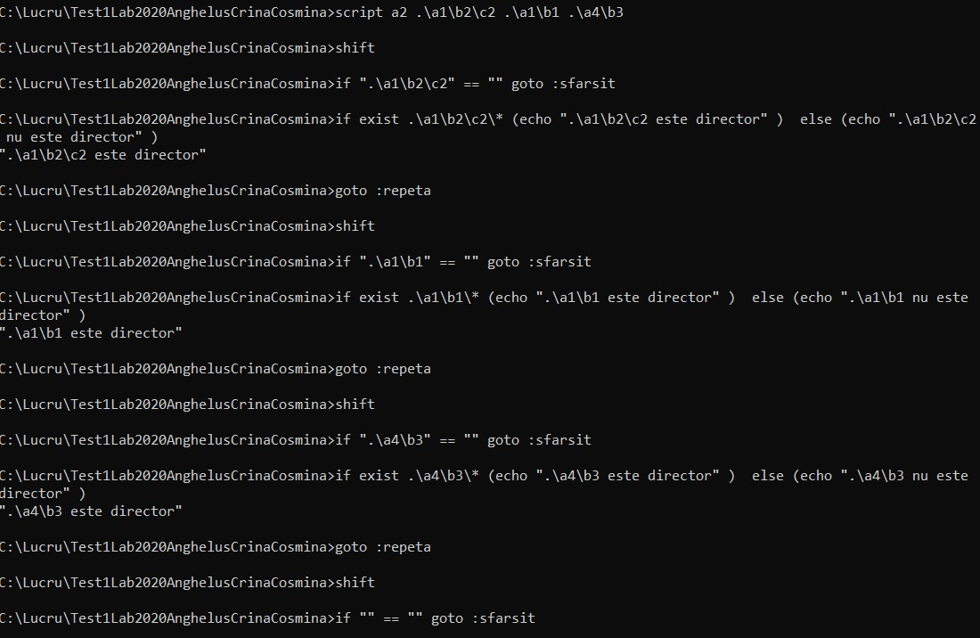

2. a)

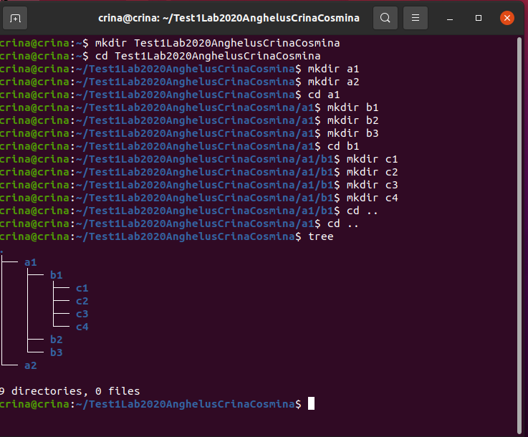

b)

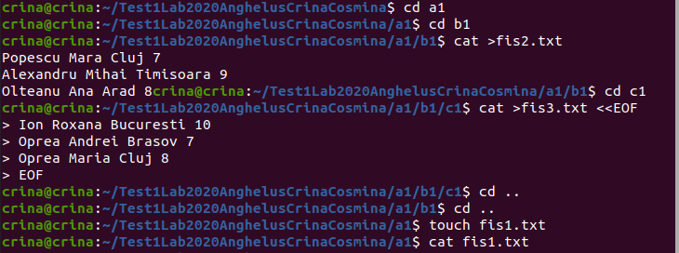



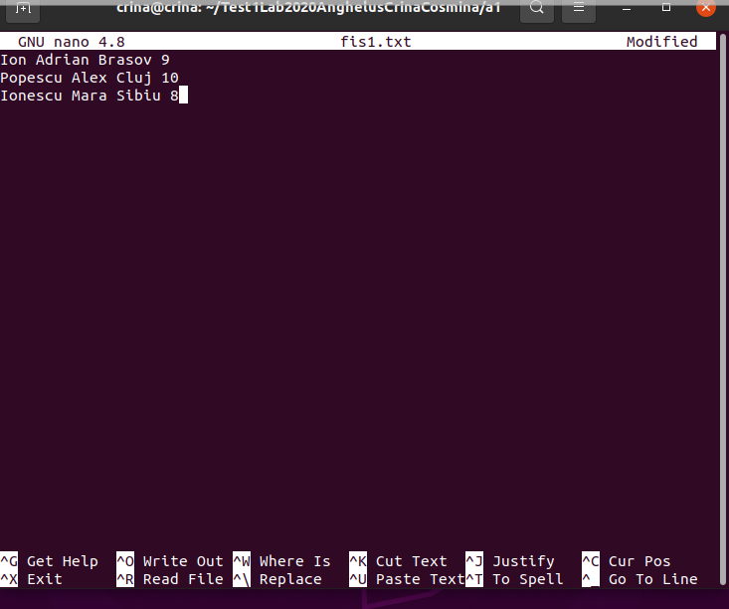

c)

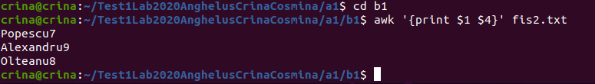

d)

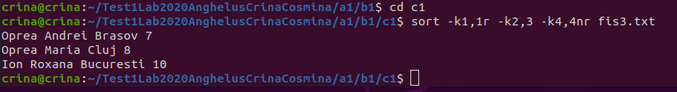

e)

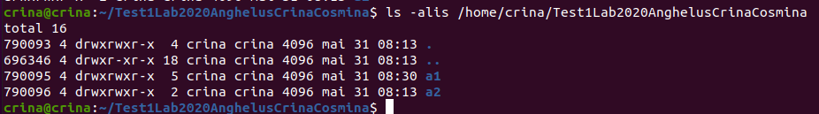

f)

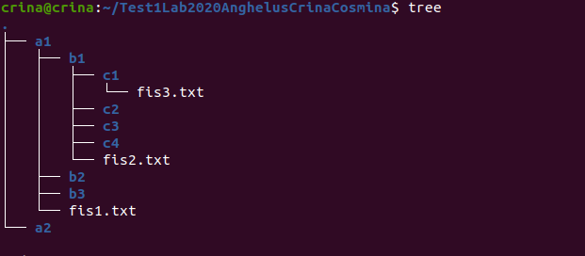

g)

echo -n "Scrieti numele directorului pe care doriti sa il cautati: "

read dir

for filename in "./$dir"/\*

do

if (-d $filename)

then

for file in \*

do

[ -w $file ]&& W="Write = yes" || W="Write = No"

[ -x $file ] && X="Execute = yes" || X="Execute = No"

[ -r $file ] && R="Read = yes" || R="Read = No"

if($W=="Write = yes"&&X="Execute = yes"&&R="Read = yes")

echo &file

enddo

fi

else echo "$filename nu este director"

fi

done

3.

I.

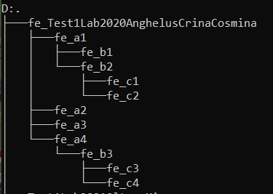

II.

a)



b)

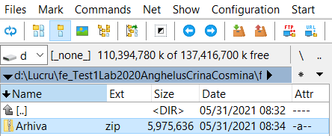

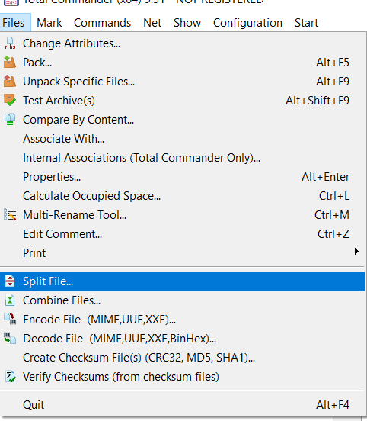

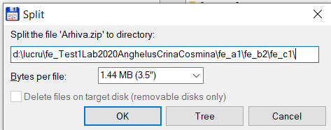

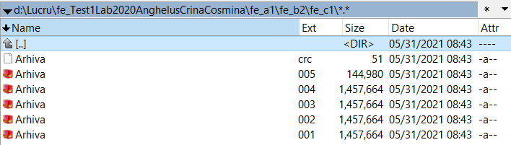

c)



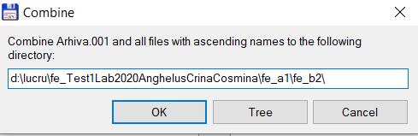

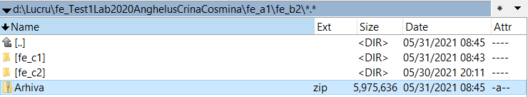

d)

